**Ksheera Requirements** :

Dimensions to fit all electronics (waterproof encasing)

Electronic components + jumper cables from and to the controller :

For Arduino mega

| **Length** | **101.52 mm** |
| --- | --- |
| **Width** | **53.3 mm** |

For rpi pico plus extra pinout shield

| **Length (mm)** | **70mm** |
| --- | --- |
| **Width (mm)** | **41mm** |

Communication lora module

| Dimensions | **19.95 x 23 x 1mm** |
| --- | --- |

Antenna of the following will go on the outside of the bot

The gps module

Dimensions **79.8 x 49.8 x 19.8 mm**

BLDC or thrusters will go on the outside of the robot for maneuverability and thrust force for the bot

The bldc will need to be outside and the speed controller should be in the water tight encasing

If possible they should be separated from main sample collection ar

# ESP32 WiFi-BT-BLE MCU Module / ESP-WROOM-32 : **26.0mm x 18.0mm x 3.0mm**

BMP280 Pressure Sensor : **40 x 40 x 40 mm**

MPU 6050 : **4×4×0.9 mm**

25.9V 2200mAh Li-Ion Battery pack : **126mm x 18mm x 67 mm**

Accelerometer : **21 x 16 x 4 mm**

Water Pumps : **100 x 80 x 80 mm**

pH Sensor : ‎**450 × 320 × 2000 mm**

Dissolved Oxygen Sensor : **42mm x 32mm**

Water temperature sensor : **1219 x 991 x 25 mm**

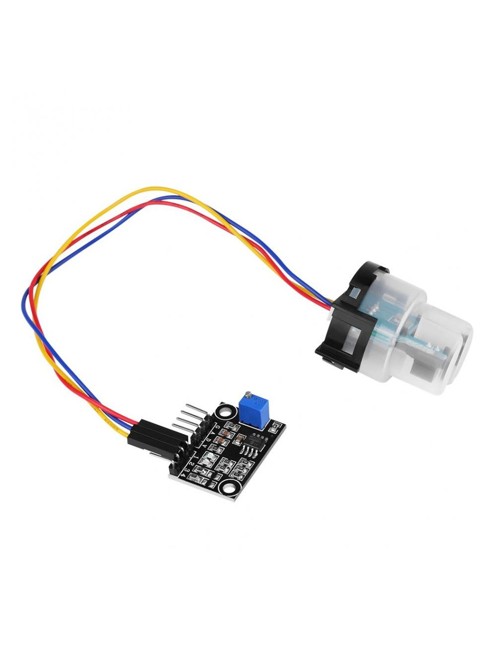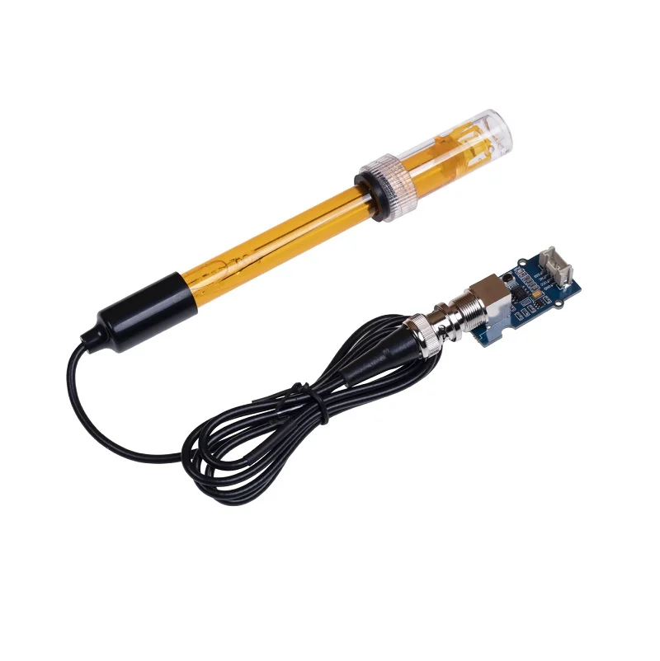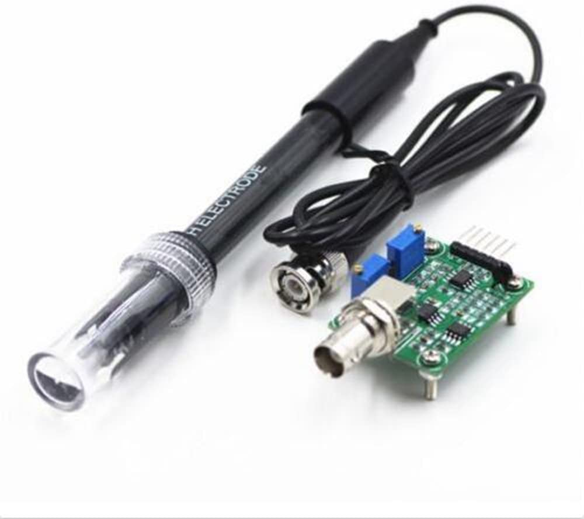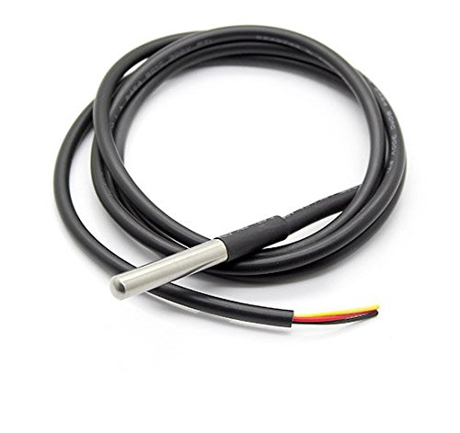

**Turbidity Sensor grove orp dissolved o2 ph sensor temperature probe sensor**

The sensors above are in the design of an electrode , we have to take a sample of water from the point of the ocean and then take the readings with these electrodes

We will need a sample collection chamber and we need to insert these electrodes in the chamber for the results.

The high powered electronics should be separated as they can affect the temperature readings of the small sample .

We would also need the ballast tank mechanism for the sinking and floating of the bot

We would also further require two more lateral thrusters or whichever design or technique which would seem fit for our application.

As we are aware the dimensions for the ballast tank dimensions will depend upon the size of the design and volume of the design.

<https://drive.google.com/file/d/1DaJKEvu4-knB3y1-GNKyrdFAsXB4naUg/view?usp=sharing>

The above link will open a spreadsheet for the weights of the components and the total weight of the bot if that's helpful.